AWS Interview Question and Ans Self
===================================================
1) What is Loopback Address ?
Loopback address ek special IP hota hai jo same machine ko refer karta hai.
Iska use system apne aap se communication ke liye karta hai.
👉 Example:
127.0.0.1 or localhost
🎯 DNS – Short Questions & Answers (Revision Set)
(Based on your notes )

🔹 Basic Questions
Q1. DNS kya hai?
👉 DNS ek system hai jo domain name ko IP address me convert karta hai.

Q2. DNS ka full form kya hai?
👉 Domain Name System

Q3. DNS ka main kaam kya hai?
👉 Domain → IP mapping (name to number conversion)

Q4. Example do DNS ka
👉 www.google.com → 142.250.x.x

🔹 Working Related
Q5. Jab browser me URL dalte hain to first step kya hota hai?
👉 Browser cache check

Q6. DNS resolution ka flow kya hai?
👉 Browser → OS → Router → ISP Resolver → Root → TLD → Authoritative → IP

Q7. Recursive resolver kya hota hai?
👉 Jo DNS query ka final answer laane tak sab servers se poochta hai

Q8. Authoritative DNS server kya karta hai?
👉 Domain ka final IP address provide karta hai

Q9. Root server ka role kya hai?
👉 TLD server ka address batata hai

Q10. TLD server kya karta hai?
👉 Domain ke authoritative server ka path deta hai

🔹 DNS Records
Q11. A record kya hota hai?
👉 Domain → IPv4 address

Q12. AAAA record kya hota hai?
👉 Domain → IPv6 address

Q13. CNAME kya karta hai?
👉 Ek domain ko dusre domain par point karta hai

Q14. MX record kya hota hai?
👉 Mail server define karta hai

Q15. NS record kya hota hai?
👉 Authoritative name servers batata hai

🔹 Technical Questions
Q16. DNS ka port number kya hai?
👉 Port 53

Q17. DNS UDP use karta hai ya TCP?
👉 Mostly UDP (normal queries), TCP (large data / zone transfer)

🔹 Load Balancer
Q18. DNS Load Balancing kya hai?
👉 Ek domain ke liye multiple IP dekar traffic distribute karna

Q19. Round Robin kya hai?
👉 Requests ko sequence me different servers par bhejna

Q20. Geo-based routing kya hai?
👉 User ke location ke basis par nearest server select karna

🔹 Security
Q21. Firewall ka role kya hai?
👉 Network ko unauthorized/malicious traffic se protect karta hai

🔹 One-Liners (Most Important 🔥)
Q22. DNS ek line me explain karo
👉 DNS internet ka phonebook hai jo name ko IP me convert karta hai

Q23. DNS resolution ek line me
👉 Domain ko IP me convert karne ka process

Q24. DNS ka real life example
👉 Contact name → phone number lookup

🚀 Ultra Short Revision (10 sec memory)
👉 DNS = Name → IP
👉 Flow = Cache → Resolver → Root → TLD → Authoritative
👉 Port = 53
👉 Records = A, AAAA, MX, CNAME
👉 Use = Website access

Perfect 👍 ab is Session 4 (TCP/UDP + TCP vs IP) ko hum short Q&A revision format me convert karte hain — exactly interview-ready 🔥

🎯 TCP, UDP & IP – Short Q&A (Revision Set)

🔹 TCP (Transmission Control Protocol)
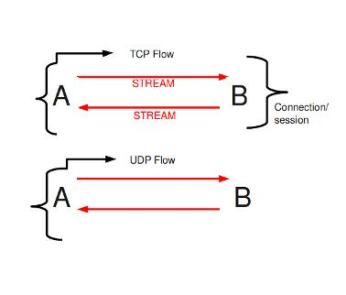
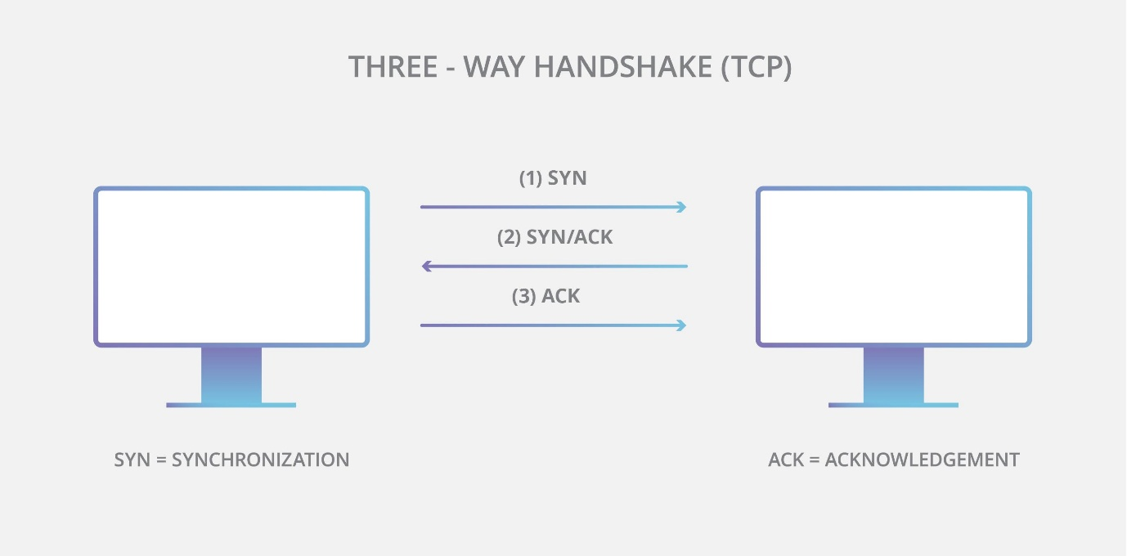
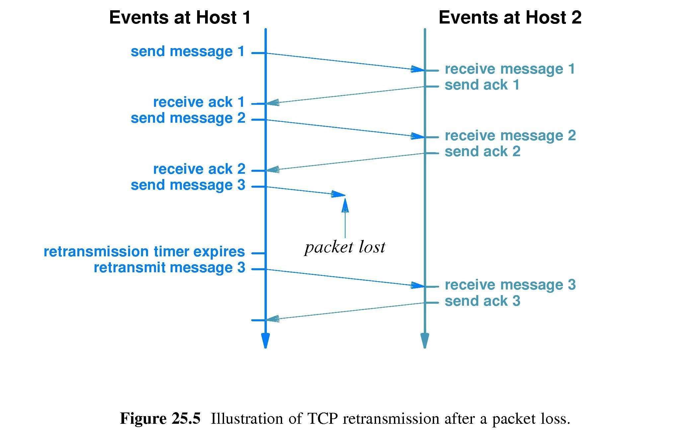
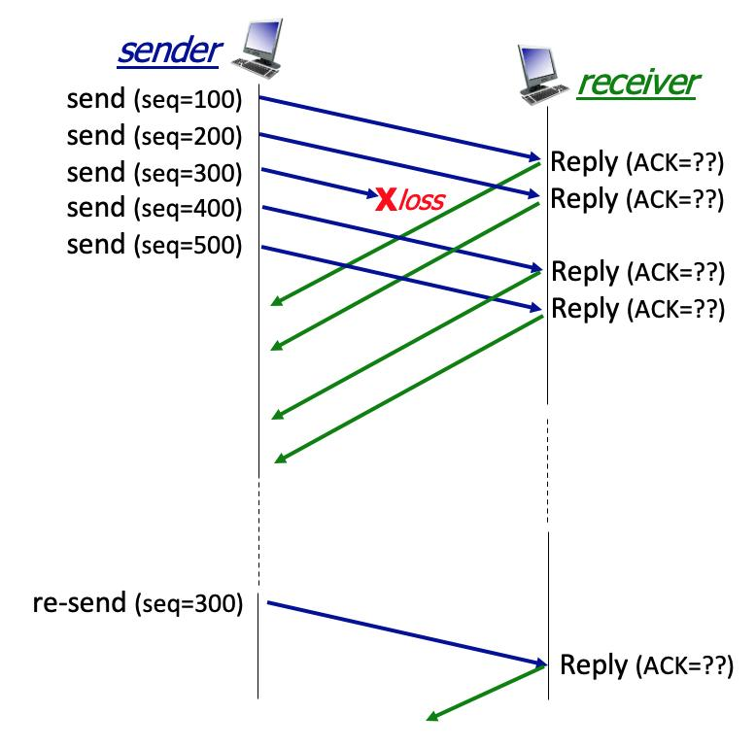
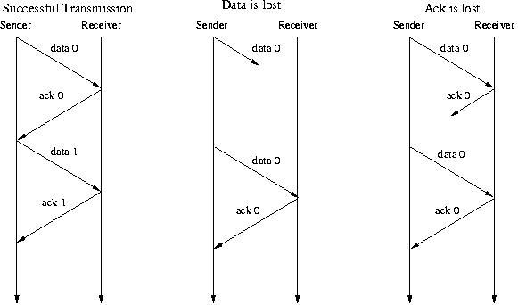
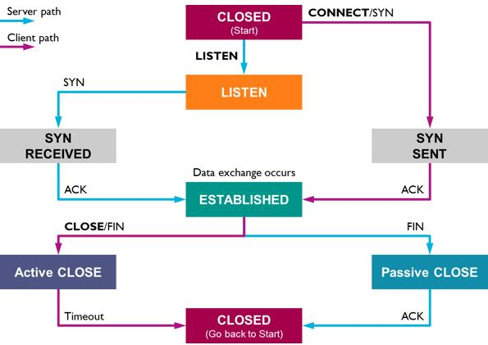
Q1. TCP kya hai?
👉 TCP ek reliable transport protocol hai jo data ko correct order me deliver karta hai.

Q2. TCP connection-oriented hai ya nahi?
👉 Yes, connection-oriented (3-way handshake)

Q3. TCP reliable kaise hai?
👉 Lost packet hone par resend karta hai

Q4. TCP me error handling hoti hai?
👉 Yes, error detect + retransmission

Q5. TCP ka real-life example?
👉 Courier / Registered Post

Q6. TCP kaha use hota hai?
👉 HTTP, HTTPS, FTP, Email

🔹 UDP (User Datagram Protocol)
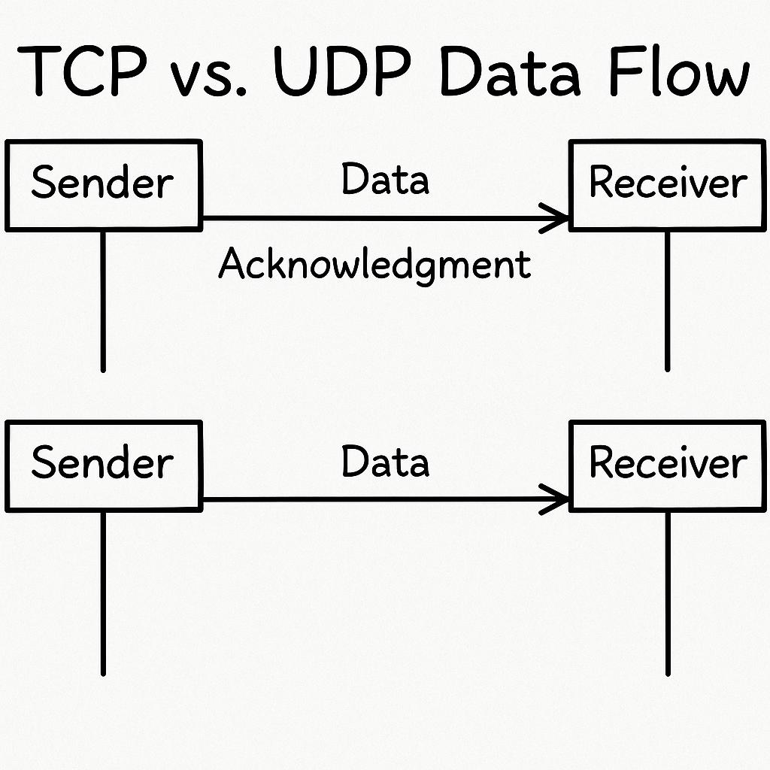
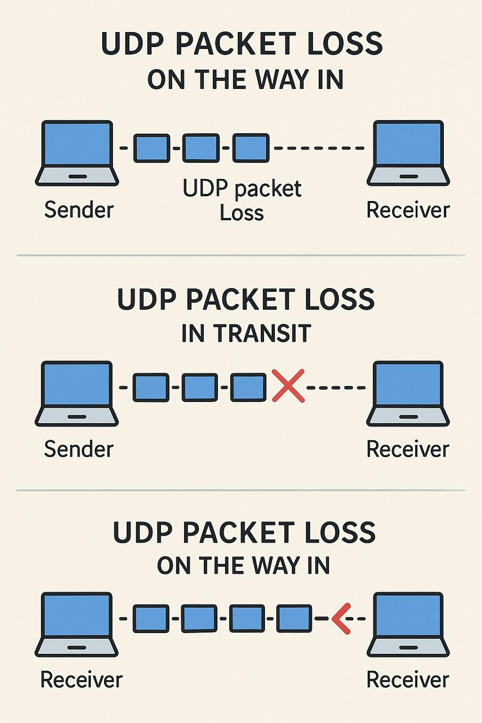
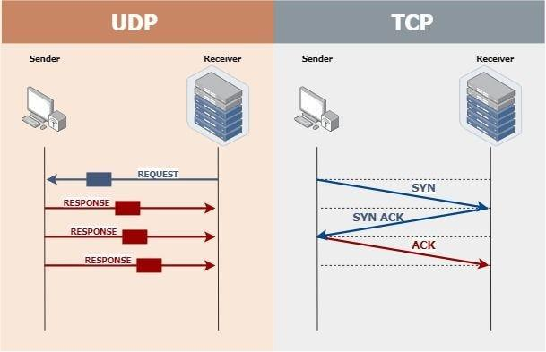
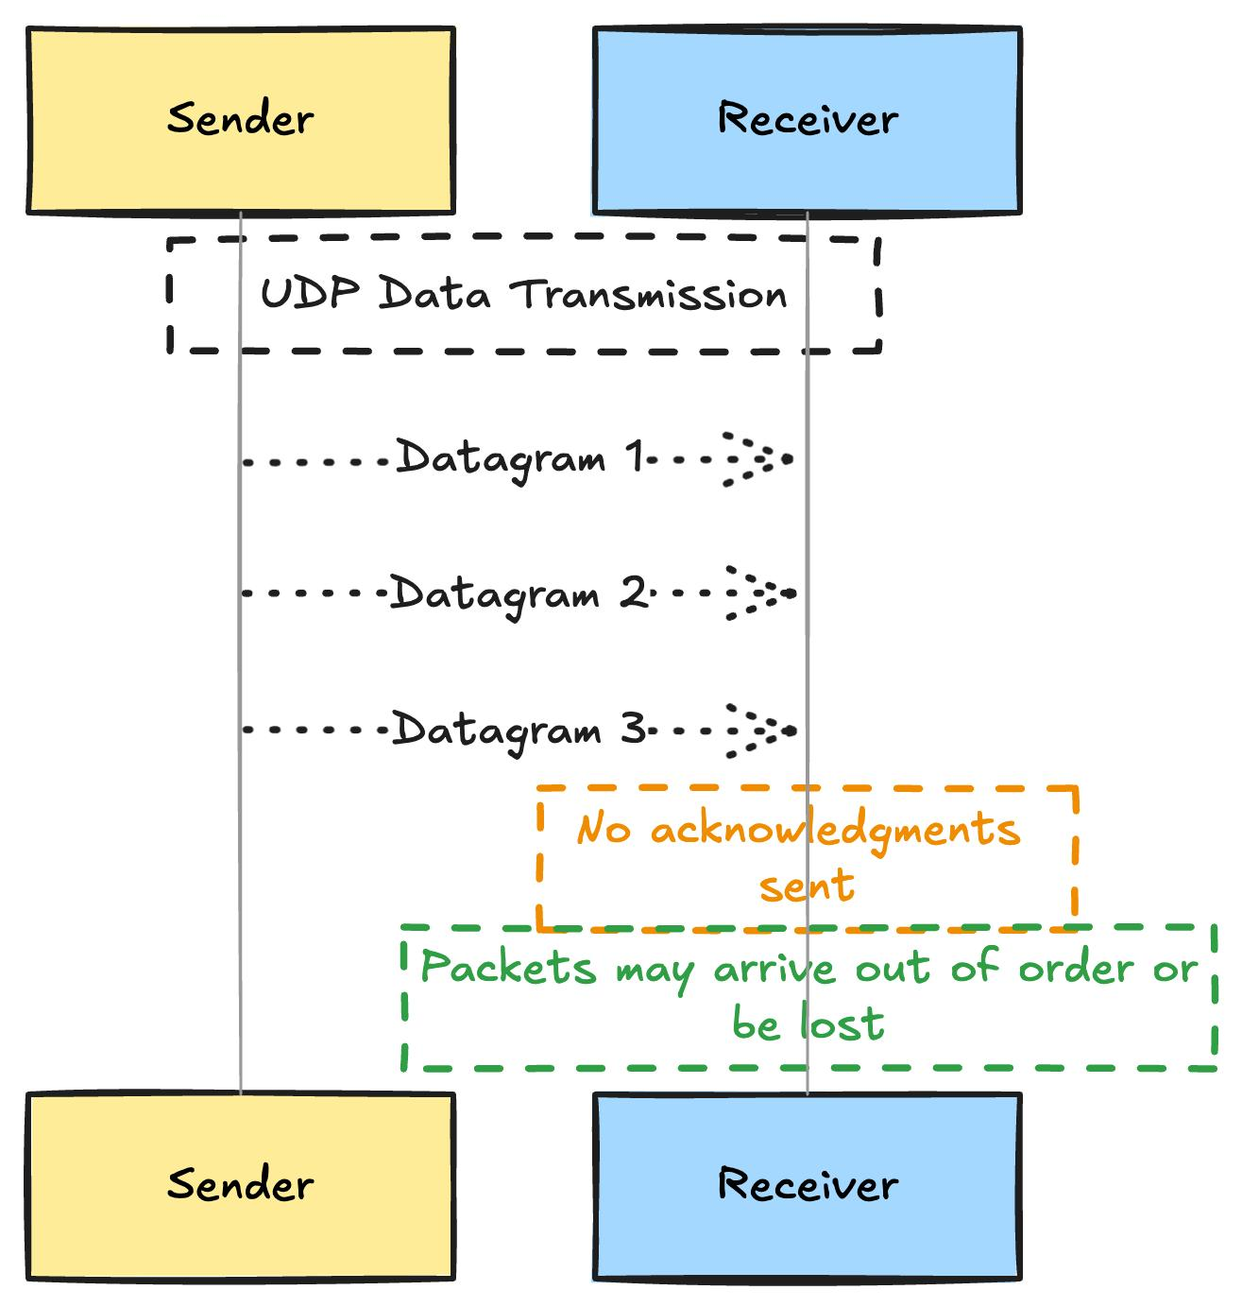
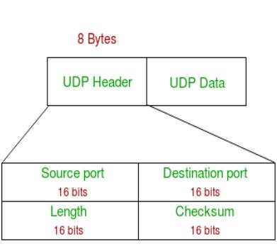
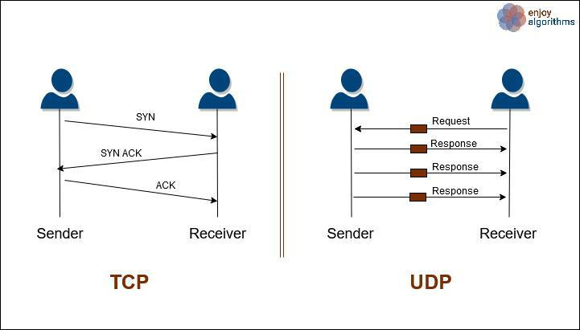
Q7. UDP kya hai?
👉 UDP ek fast, connectionless protocol hai

Q8. UDP reliable hai?
👉 No, no guarantee of delivery

Q9. UDP fast kyun hai?
👉 Kyunki no handshake, no resend

Q10. UDP me order guarantee hota hai?
👉 No

Q11. UDP ka real-life example?
👉 Postcard / WhatsApp message

Q12. UDP kaha use hota hai?
👉 Streaming, Gaming, DNS

🔹 TCP vs UDP (Important 🔥)
Q13. TCP vs UDP ek line me
👉 TCP = reliable but slow, UDP = fast but unreliable

Q14. Kaun fast hai TCP ya UDP?
👉 UDP

Q15. Kaun reliable hai?
👉 TCP

🔹 TCP vs IP
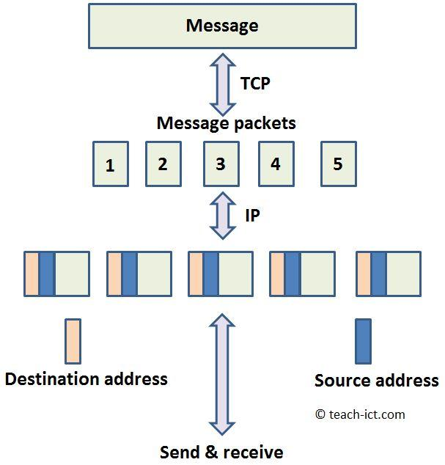
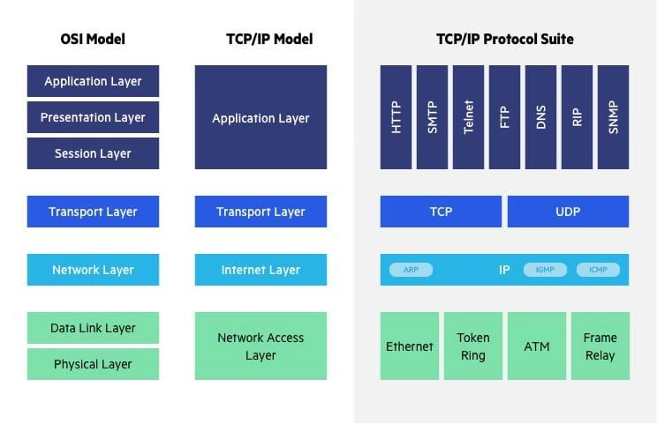
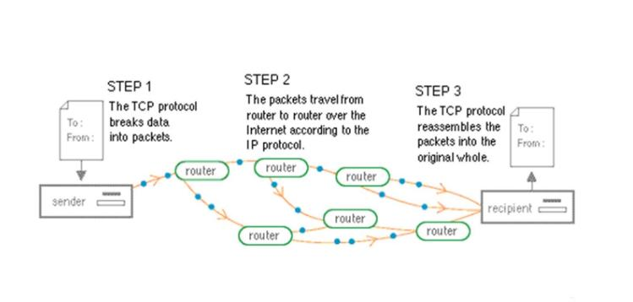
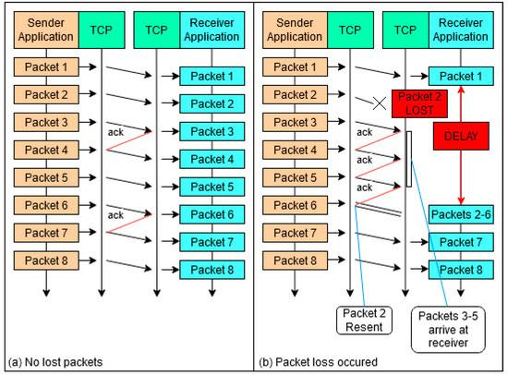
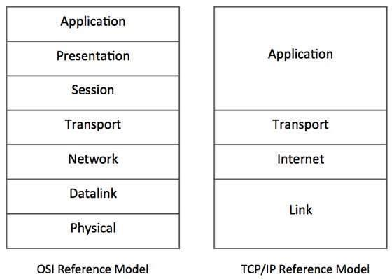
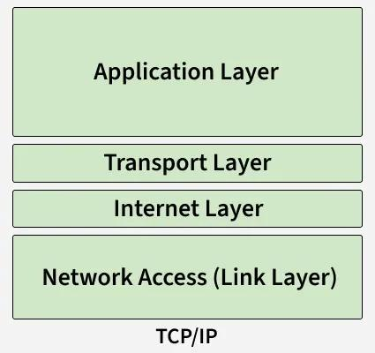
Q16. TCP kya karta hai?
👉 Reliable data delivery

Q17. IP kya karta hai?
👉 Packet ko destination tak route karta hai

Q18. TCP ka layer kaunsa hai?
👉 Transport Layer

Q19. IP ka layer kaunsa hai?
👉 Internet Layer

Q20. IP reliable hai?
👉 No

Q21. TCP/IP ka relation kya hai?
👉 IP data ko pahunchata hai, TCP ensure karta hai ki data sahi mile

🔥 Most Important One-Liners (Interview)
Q22. TCP ek line me
👉 Reliable, connection-oriented protocol

Q23. UDP ek line me
👉 Fast, connectionless protocol

Q24. TCP vs UDP ek line me
👉 TCP reliable hai, UDP fast hai

Q25. TCP vs IP ek line me
👉 TCP delivery karta hai, IP routing karta hai

🚀 Ultra Short Revision (10 sec)
👉 TCP = Reliable + Handshake
👉 UDP = Fast + No guarantee
👉 IP = Routing
👉 TCP/IP = Delivery + Routing

Perfect Vishnudas 👍
Ab main is Session 4 (TCP/IP Model + URL + Protocols) ko very short Q&A revision format me convert kar raha hoon — exactly interview ready 🔥
(Based on your notes )

🎯 TCP/IP Model + URL – Short Q&A

🔹 TCP/IP Model
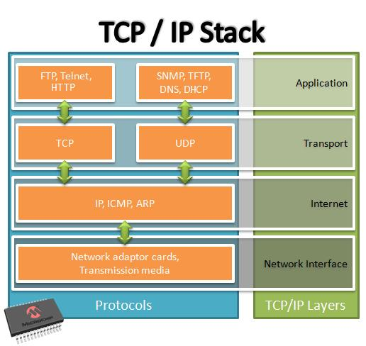
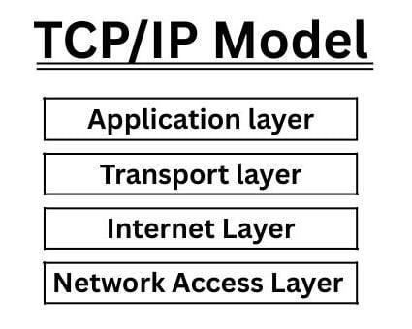
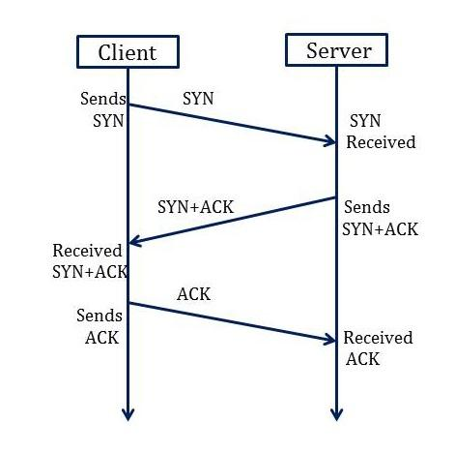
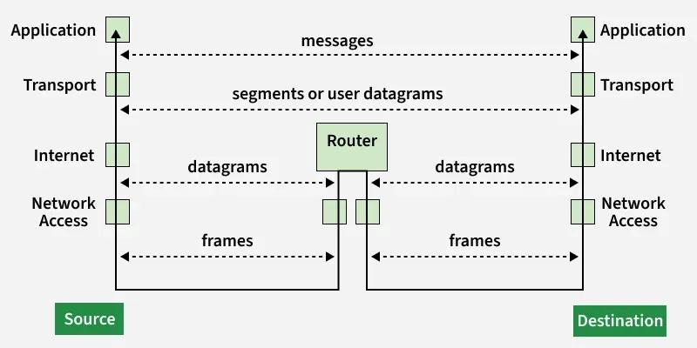
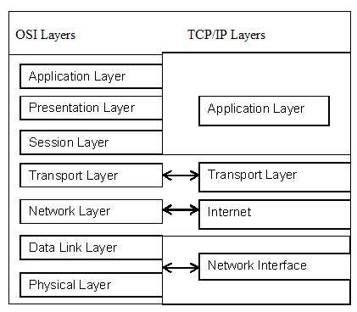
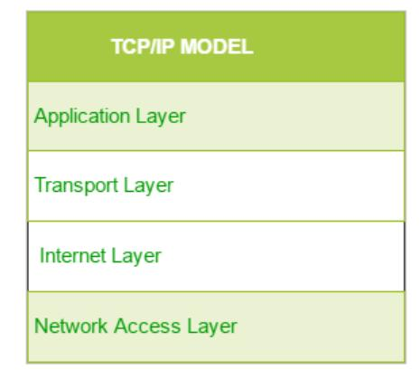
Q1. TCP/IP model kya hai?
👉 Network communication model with 4 layers

Q2. TCP/IP me kitni layers hoti hain?
👉 4 Layers

Q3. TCP/IP layers ka order?
👉 Application → Transport → Internet → Network Access

Q4. Application layer ka kaam kya hai?
👉 User-level communication (HTTP, FTP)

Q5. Transport layer ka kaam?
👉 Data delivery (TCP/UDP)

Q6. Internet layer kya karti hai?
👉 Routing & IP addressing

Q7. Network Access layer kya karti hai?
👉 Physical data transfer (Wi-Fi, Ethernet)

Q8. Data flow kaise hota hai?
👉 Sender: App → Transport → Internet → Network
👉 Receiver: Reverse

🔹 URL (Uniform Resource Locator)
Q9. URL kya hai?
👉 Web address of a resource

Q10. URL ke main parts kya hain?
👉 Protocol + Domain + Port + Path + Query + Fragment

Q11. Protocol kya hota hai URL me?
👉 Communication method (HTTP/HTTPS)

Q12. Domain kya hota hai?
👉 Website ka naam (e.g., google.com)

Q13. Port number kya hota hai?
👉 Server ka communication endpoint

Q14. Path kya hota hai?
👉 Specific page location (/page1)

Q15. Query string kya hota hai?
👉 Extra data (?id=123)

Q16. Fragment kya hota hai?
👉 Page ka specific section (#section)

🔹 HTTP vs HTTPS
Q17. HTTP kya hai?
👉 Non-secure protocol (Port 80)

Q18. HTTPS kya hai?
👉 Secure protocol with encryption (Port 443)

Q19. HTTP vs HTTPS difference ek line me
👉 HTTP not secure, HTTPS encrypted

🔹 Internet Protocol (IP)
Q20. IP kya hai?
👉 Device ka unique address network me

Q21. IP ka kaam kya hai?
👉 Packet routing & delivery

🔹 DNS + URL Flow (Important 🔥)
Q22. URL access ka flow kya hai?
👉 Browser → DNS → IP → Server → Response

Q23. DNS ka role kya hai?
👉 Domain ko IP me convert karta hai

🔹 TCP vs UDP (Quick)
Q24. TCP kya hai?
👉 Reliable protocol

Q25. UDP kya hai?
👉 Fast but unreliable

🔥 Most Important One-Liners (Interview)
Q26. TCP/IP model ek line me
👉 Communication framework with 4 layers

Q27. URL ek line me
👉 Web resource ka structured address

Q28. HTTP vs HTTPS ek line me
👉 HTTP insecure, HTTPS secure

Q29. IP ek line me
👉 Unique address for device identification

🚀 Ultra Short Revision (10 sec)
👉 TCP/IP = 4 Layers
👉 URL = Protocol + Domain + Path
👉 HTTP = 80, HTTPS = 443
👉 IP = Address
👉 DNS = Name → IP

